Part Number: PT347-12160 (Scion) Part Number: PT347-12161 (Toyota)
Kit Contents
Item # | Quantity Reqd. | Description
1 | 1 | Convenience Net
Hardware Bag Contents
Item # | Quantity Reqd. | Description
Additional Items Required For Installation
Item # | Quantity Reqd. | Description
Conflicts
Recommended Tools
Personal & Vehicle Protection | Notes
None
Special Tools | Notes
None
Installation Tools | Notes
None
Special Chemicals | Notes
None
General Applicability
Vehicle Service Parts (may be required for reassembly)
Item # | Quantity Reqd. | Description
Recommended Sequence of Application
Item # | Accessory
*Mandatory
Legend
STOP: Damage to the vehicle may occur. Do not proceed until process has been complied with.
OPERATOR SAFETY: Use caution to avoid risk of injury.
CAUTION: A process that must be carefully observed in order to reduce the risk of damage to the accessory/vehicle and to ensure a quality installation.
TOOLS & EQUIPMENT: Used in Figures calls out the specific tools and equipment recommended for this process.
REVISION MARK: This mark highlights a change in installation with respect to previous issue.
SAFETY TORQUE: This mark indicates that torque is related to safety.

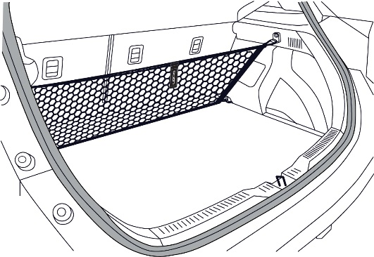

Care must be taken when installing this accessory to ensure damage does not occur to the vehicle. The installation of this accessory should follow approved guidelines to ensure a quality installation.

These guidelines can be found in the "Accessory Installation Practices" document.

This document covers such items as:-
• Vehicle Protection (use of covers and blankets, cleaning chemicals, etc.).
• Safety (eye protection, rechecking torque procedure, etc.).
• Vehicle Disassembly/Reassembly (panel removal, part storage, etc.).
• Electrical Component Disassembly/Reassembly (battery disconnection, connector removal, etc.).

Please see your dealer for a copy of this document.

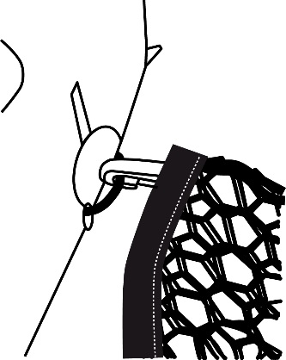
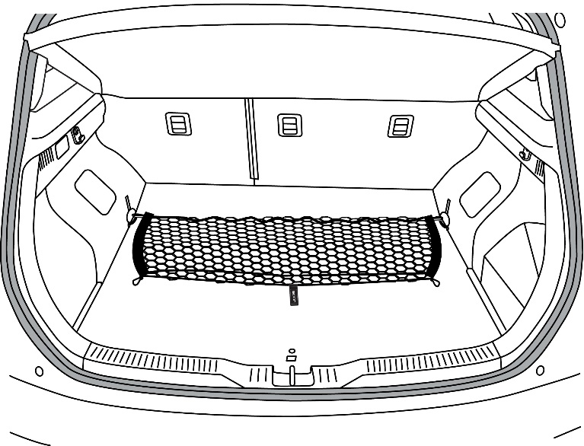
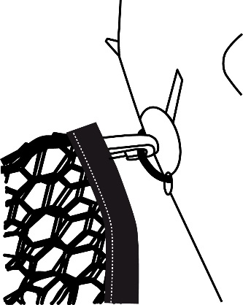
1

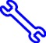

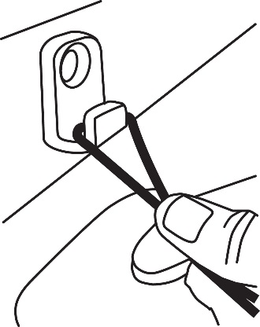
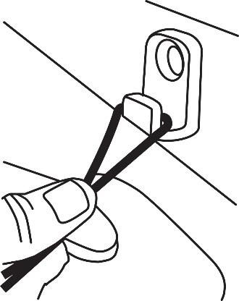
2

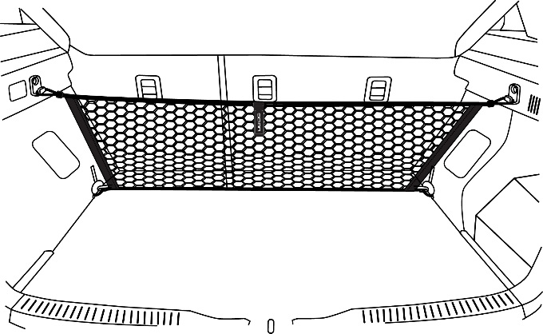
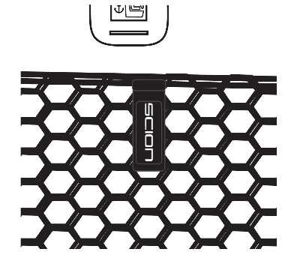
3

Accessory Function Checks

Confirm that the net is attached properly to the anchor points in the vehicle.

Vehicle Function Checks

Vehicle hatch door operation.

Confirm pull tab is facing toward the rear of the vehicle.
Confirm upper loops at the top of the net are attached to the upper L-Anchors of the vehicle.
Confirm the lower clips at the bottom of the net are attached to the lower D-Rings of the vehicle.

Confirm vehicle hatch door opens and closes without interference from Cargo Net.

Vehicle Appearance Check

After accessory installation and removal of protective cover(s), perform a visual inspection.

Ensure no damage (including scuffs and scratches) was caused during the installation process. (For PPO installations, refer to TMS Accessory Quality Shipping Standard.)

